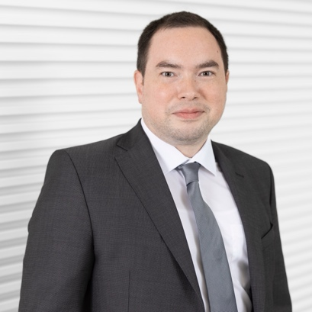**Jun.-Prof. Dr. rer. nat. Charles Imbusch**

*02.12.1983

Professor of Quantitative Biomedicine (W1)

Institute for Immunology

University Medical Center of the Johannes Gutenberg University Mainz

D-55131 Mainz, Langenbeckstr. 1, building 308A

[c.imbusch@uni-mainz.de](mailto:c.imbusch@uni-mainz.de)

[www.immunologie-mainz.de](http://www.immunologie-mainz.de)

**Academia**

2017 – 2019 Dr. rer. nat. in Bioinformatics, Heidelberg University, Germany

2004 – 2010 Diploma Bioinformatics, Jena University, Germany

**Career**

since 2023 Tenured Professor (W1) for Quantitative Biomedicine, Institute of Immunology, University Medical Center, Mainz, Germany

since 2018 Teamleader for Computational Oncoimmunology within Department of Applied Bioinformatics, DKFZ Heidelberg, Germany

2019 - 2023 Postdoctoral scientist, Department of Applied Bioinformatics, DKFZ Heidelberg, Germany

**Selected Publications**

Lutz R, Grünschläger F, Simon M, …, Brors B*, Goldschmidt H*, **Imbusch CD**\*, Hundemer M*, Haas S*. Multiple myeloma long-term survivors exhibit sustained immune alterations decades after first-line therapy, Nat Commun. 2024 Nov 29;15(1):10396. doi: 10.1038/s41467-024-54543-0.

Delacher M*, Schmidleithner L*, Simon M*, Stüve P*, …, **Imbusch CD**, Feuerer M. The Effector Program of Human CD8 T Cells Supports Tissue Remodeling, Journal of Experimental Medicine. 2024 Feb 5;221(2):e20230488., doi: 10.1084/jem.20230488

Kandala S, Ramos M, Voith von Voithenberg L, Diaz-Jimenez A, Chocarro S, Keding J, Brors B**, Imbusch CD**, Sotillo R. Chronic Chromosome Instability Induced by Plk1 Results in Immune Suppression in Breast Cancer, Cell Reports. 2023 Dec 26;42(12):113266. doi: 10.1016/j.celrep.2023.113266

Malte Simon*, Sadaf S Mughal*, Peter Horak, Sebastian Uhrig, Jonas Buchloh, Bogac Aybey, Albrecht Stenzinger, Hanno Glimm, Stefan Fröhling, Benedikt Brors, **CD Imbusch**, Deconvolution of sarcoma methylomes reveals varying degrees of immune cell infiltrates with association to genomic aberrations, J Transl Med. 2022 Apr 2;20(1):152. doi: 10.1186/s12967-022-03316-8

Delacher M*, **Imbusch CD\***, Weichenhan D, Breiling A, Hotz-Wagenblatt A, Träger U, Hofer AC, Kägebein D, Wang Q, Frauhammer F, Mallm JP, Bauer K, Herrmann C, Lang PA, Brors B, Plass C, Feuerer M., Genome-wide DNA-methylation landscape defines specialization of regulatory T cells in tissues., Nat Immunol. 2017 Oct;18(10):1160-1172. doi: 10.1038/ni.3799. Epub 2017 Aug 7.